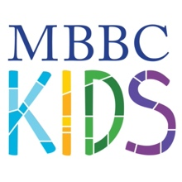

Sunday Mornings
Worship 9:00 & 11:00 am (worship care provided for 2K & under)
- 3K-5K (preschool worship)
- Waffles with Wayne
Sunday School 10:00 am
Child’s Birthday – Celebrate in SS or Missions

Wednesday Nights (beginning September 7)
Dinner 5:00 pm
Missions 5:30 pm
Music 6:15 pm

Important Stuff
September 11 at 10:00 am in Hudson Hall – How to Become A Christian

October 2, 9 & 16 – 5:00-6:00 pm – School Age Bible Skills

Mom’s Connect
September 15 – 10:00 am – Sharon’s House

October 11– 6:00 pm – Sharon’s House

Fun Stuff

September 11 – School Age swim – Sharon’s House
1st grade – 1:30-2:30 – Popsicles & Pool

2nd/3rd grade – 2:45-3:45 – Popsicles & Pool

4th-6th grade– 4:00-5:00 – Pizza & Pool

September 25 -- Family Picnic on the lawn – 4:00-5:30 pm
Play on the playgrounds or gym

October 15 – Serve Day (Kid’s on Mission)

October 30 – Trunk or Treat – 4:00-6:00 pm

November 20 – Thanksgiving Lunch (PIE DAY!)

Thinking Ahead….
December 20-22 – The Living Nativity

July 10-14 VBS

July 23-27 Children’s Camp YMCA Camp Chandler

